|  |
| --- |
| CS590BD Big Data Analytics and Applications |
| Lab 2 Assignment |
| Goutham Marikanti  16171450 |

TASK 1

# Implement an application to generate a file showing any four of the given activities.

* Import the project from Blackboard and run it on your machine with slight modifications based on the activities you want to run.
* I chose the following activities:
* Accelerometer
* GPS
* Gyroscope
* Date and Time

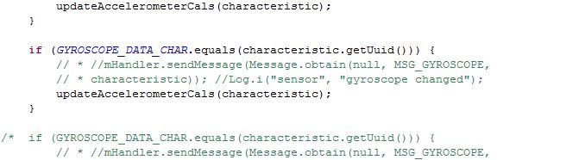

* Then run the application on your Android device.
* Turn the Sensor Tag ‘ON’ and move it around to make the values change.
* The following file will be generated on your android device.

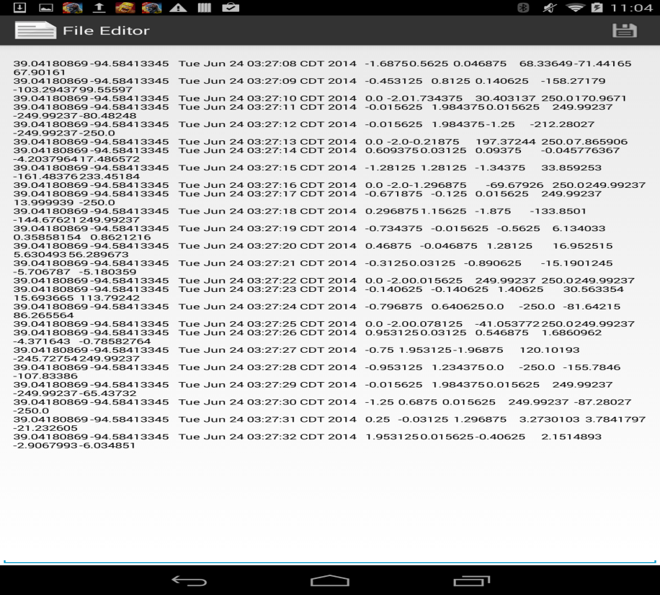

* You can download “Astro File Manager ” to browse your Android device and find this file.

TASK 2

# Insert the generated file into HBASE

* Connect to Hbase via UMKC VPN.
* Import the code and run it on your machine.

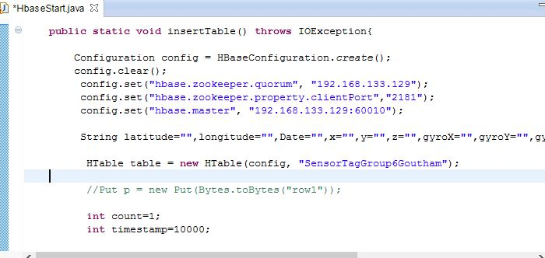

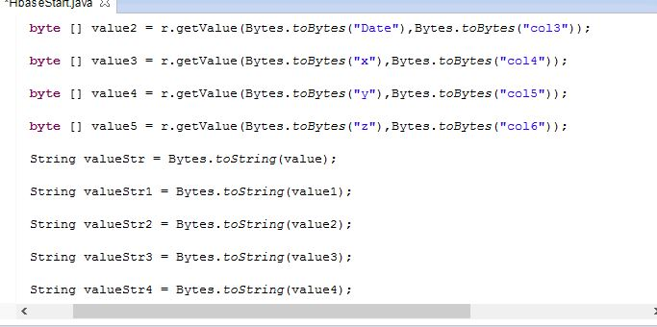

* Now run the application to Create and retrieve the Table.

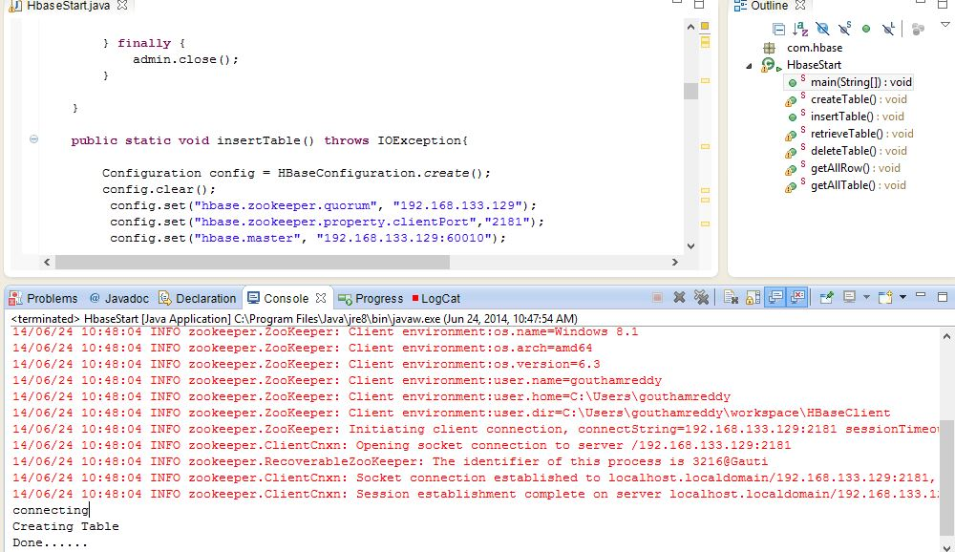

* This is how the table will look like.

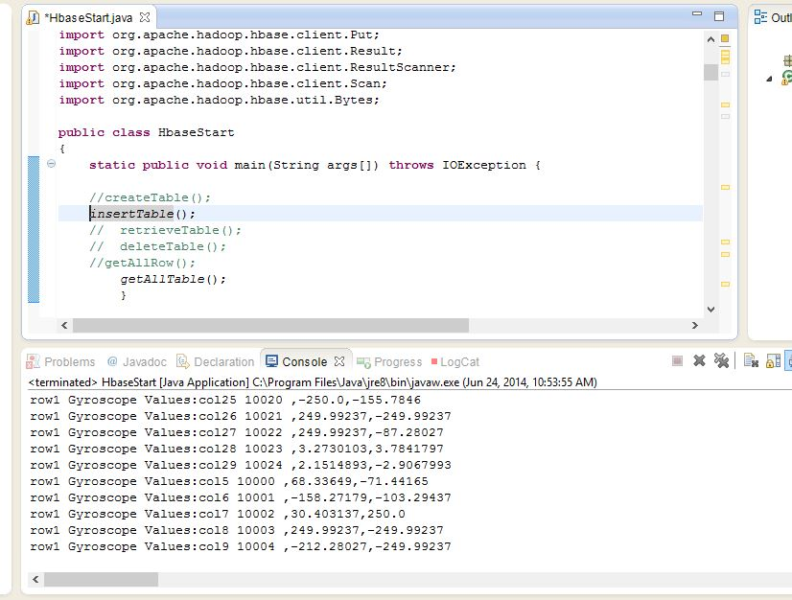

This is how the data is inserted into Hbase.